**What is the CQRS?**

**Notes:-**

**1-CQRS: command and query responsibility segregation , which means that we separate each operation into separate class with splatted into query or command**

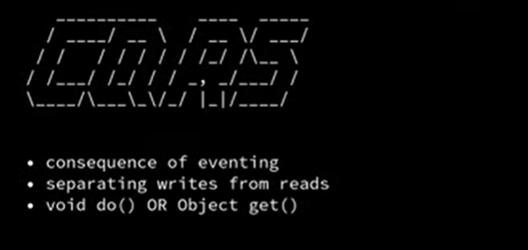

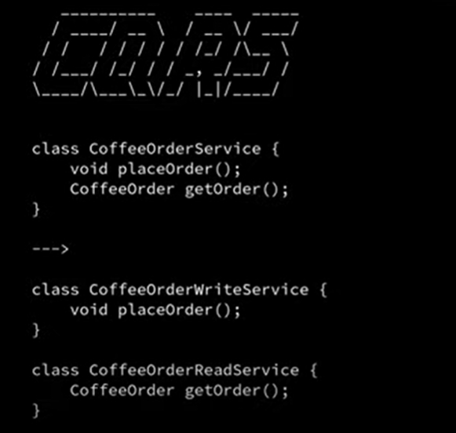

**We see that write is class and read is class into separate folders**

**2-CQRS applied event sourcing in order to store events into event source that is taken one by one async**

**3-the important thing that in CQRS pattern the command service has separate context than the query service also so it handle the concrete transaction at the same time**

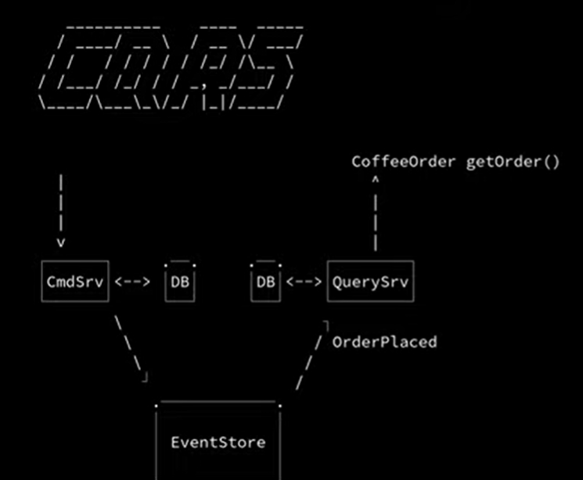

**There is an event store which like queue that store events and internally there is consumer that consume those event in order way because each event is store with order**

